# Pivotal Tracker (Planning Application)

For out project plan, we used Pivotal tracker to track our plan. As the time limit that we had was short, we used an agile method with extremely short sprints. This helped us keep on task and not over fall the deadline. To project plan that is within this folder is the exported data from Pivotal tracker. Here are a few screen shots of the application we used, they show all of the stories that we completed, and within the stories are the individual tasks that were ticked off as they were completed:

Completed Tasks

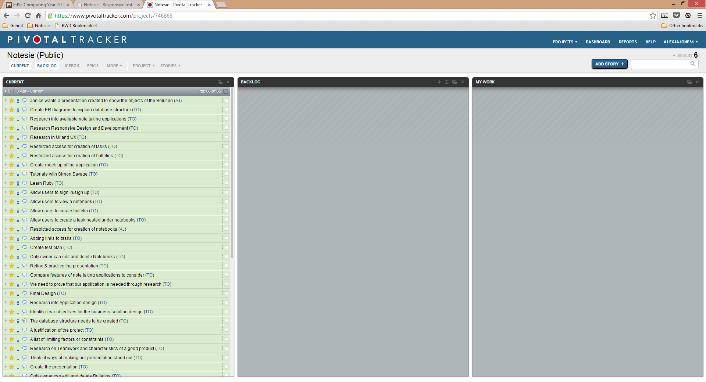

Task View New Story View

